MLUL-GROUP ASSIGNMENT

Problem 1
Question 1
Introduction and Objective:
The first task was to prepare a clean dataset that represents genuine shopper behaviour inside the mall. Employees and very short visits were excluded so that the later clustering reflects actual customer movement patterns rather than background Wi-Fi connections.
Data Understanding:
The dataset contained 7,705 visit records tracked through the mall’s Wi-Fi network. Each record includes total duration, time spent on five floors (time_0 to time_4), and section-level times for floors 2 and 3.
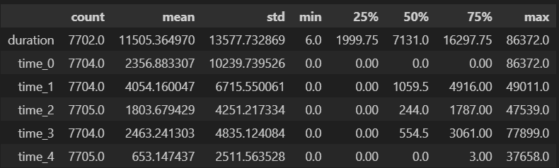
Exploratory Analysis:
Average visit duration was around 11,500 seconds (about 3 hours), but there were many quick visits under 2,000 seconds. Both total duration and total floor time were heavily right-skewed, showing that most people visit briefly while a few stay much longer.
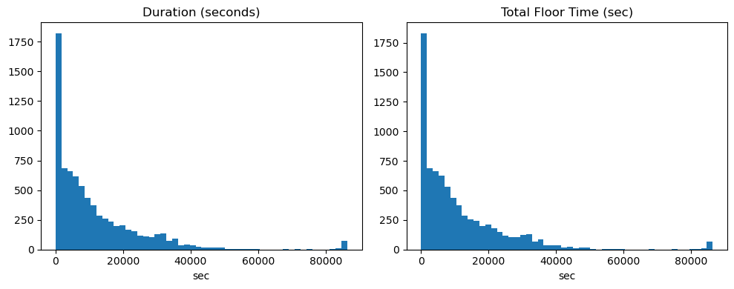
The correlation heatmap between floors showed almost no relationship (values near 0), meaning time on one floor doesn’t predict time on another.
Filtering Approach:
Records were retained only if employee_flag = 0 and duration ≥ 1800 seconds (30 minutes).
This removed employee logins and short, non-shopping connections.
Results:
Out of 7,705 records, 4,832 remained after filtering, roughly 37 percent were removed. The cleaned dataset now contains visitors who spent meaningful time in the mall and will serve as the base for all further segmentation.

Question 2
Objective and Approach:
The aim was to segment mall visitors based on how they distributed their time across different floors (levels 0–4). Instead of using raw seconds, percentages of total visit time were calculated for each floor so that the clusters reflect behavioural patterns rather than total duration. K-Means clustering was used, and the best number of clusters (k) was chosen using both the elbow and silhouette methods.
Model Selection:
K values from 2 to 8 were tested. The silhouette scores improved steadily and peaked at k = 5 (0.50), while the elbow curve also showed a clear bend at this point, confirming that five clusters represent distinct visitor behaviours.

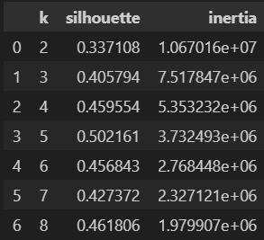
The final K-Means model with 5 clusters clearly grouped customers by their dominant floor activity.
Cluster | Dominant Floor | Key Behaviour | Share of Visitors
0 | Level 1 | Mostly concentrated on L1 (≈75%) | 39%
1 | Level 3 | Primarily leisure or entertainment (≈70%) | 28%
2 | Level 2 | Mixed shoppers who spend majority time on L2 | 22%
3 | Level 0 | Quick errands and ground-floor activity | 4%
4 | Level 4 | Visitors spending majority time on L4, possibly offices or food court | 7%
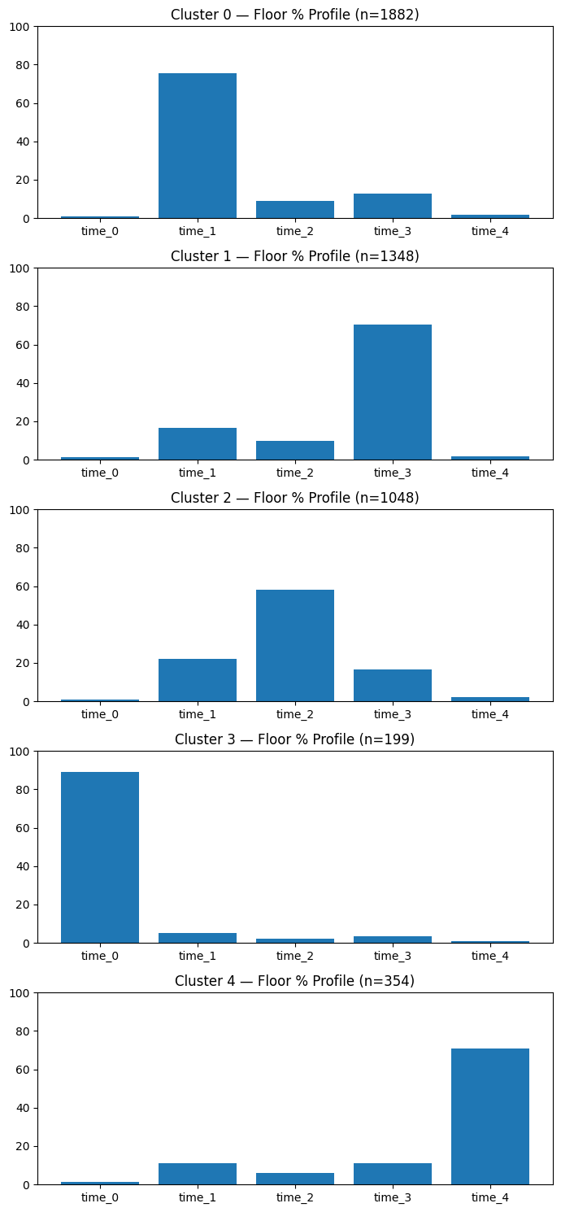
Interpretation:
- Cluster 0 (L1 Shoppers): Represents the largest group who spend nearly three-quarters of their time on Level 1, suggesting heavy retail activity.
- Cluster 1 (L3 Leisure Goers): Visitors focusing on Level 3 — likely cinema or dining zones.
- Cluster 2 (L2 Shoppers): Customers dividing most of their time on Level 2, where anchor stores and mid-range retail could be located.
- Cluster 3 (Quick Errands): People who stay mainly on Level 0 — possibly parking access, groceries, or short visits.
- Cluster 4 (L4 Visitors): A smaller group spending the bulk of time on Level 4 — possibly office workers or restaurant patrons.
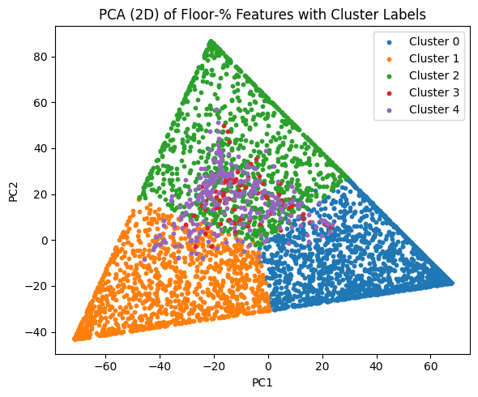
The analysis identified five distinct behavioural segments of mall visitors based on floor usage. Each cluster shows a dominant engagement pattern tied to specific mall zones, providing a clear behavioural map for space allocation, promotions, and tenant mix planning in the next phase of analysis.

Question 3
Objective and Approach:
The purpose of this step was to understand if, within a floor-focused visitor group, there are smaller behavioural sub-segments based on how customers move across different sections of that floor.
From the previous clustering, the group that spent most of its time on Level 3 (the leisure-oriented floor) was chosen. For these visitors, time spent across sections such as East, North, South, West, and their extensions was converted into percentages of total floor time.
K-Means clustering with a range of K = 2 to 7 was tested, and the silhouette score was used to select the most meaningful number of clusters.
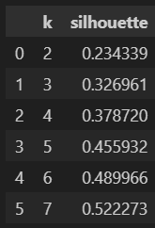
The silhouette score improved steadily and peaked at K = 7, suggesting seven distinct section-level behaviour patterns among visitors on Level 3.
Cluster | Dominant Section(s) | Key Behaviour | Share
0 | South + West mix | Balanced movement between food-court and corridor zones | ~25 %
1 | North | Leisure-zone visitors, concentrated around entertainment area | ~16 %
2 | South | Lifestyle retail and planned shoppers | ~20 %
3 | North Extension | Anchor-store or cinema visitors | ~15 %
4 | East | Focused movement in a single corridor | ~10 %
5 | West | Visitors spending most of their time in dining/exit areas | ~10 %
6 | Northeast | Small group highly concentrated in one section | ~4 %

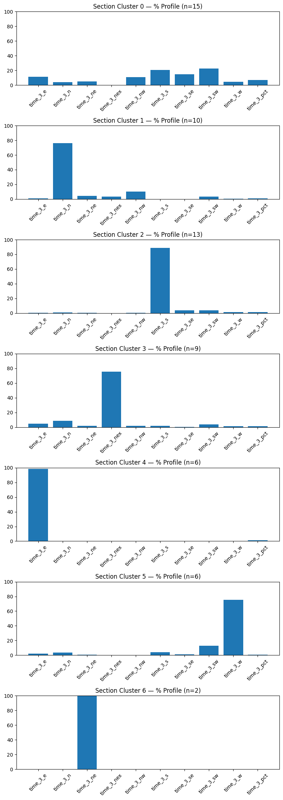

Question 2
Introduction and Business Objective: We wanted to group (segment) 50 pharmaceutical companies into similar-performance groups using their financial measures for the same quarter, so we can spot strong performers, typical companies, and unusual ones that deserve a closer look.
Data Selection: We use the pharmaceutical sector. Pharmaceuticals are suitable because companies report standardized quarterly financials, the sector has a mix of margin/volume business models (API manufacturers, formulation companies, specialty firms), and performance differences show clearly in ratios like ROE, ROA and margins — which helps clustering find meaningful groups.
Financial Ratios
1. ROA 12M % (Return on Assets - 12 Months) - Measures how efficiently a company generates profit from its total assets over the past 12 months. Formula: (Net Income / Total Assets) × 100
2. ROE % (Return on Equity) - Measures the profitability generated on shareholders equity, showing how effectively management uses investor capital. Formula: (Net Income / Shareholders' Equity) × 100
3. Debt / Equity (Debt to Equity Ratio) - Measures the proportion of debt financing relative to equity, indicating financial leverage and capital structure. Formula: Total Debt / Total Shareholders' Equity
4. Current Ratio - Measures short-term liquidity by comparing current assets to current liabilities, indicating ability to meet obligations within one year. Formula: Current Assets / Current Liabilities
5. Sales Growth % - Year-over-year percentage increase in revenue, indicating top-line expansion and market demand. Formula: [(Current Period Sales - Previous Period Sales) / Previous Period Sales] × 100
6. ROCE % (Return on Capital Employed) - Measures profitability and efficiency in deploying both equity and debt capital into operations. Formula: (EBIT(Earnings Before Interest and Taxes) / Capital Employed) × 100
where Capital Employed = Total Assets - Current Liabilities
7. Asset Turnover - Measures revenue generation efficiency per rupee of assets, showing operational effectiveness. Formula: Net Sales / Average Total Assets
8. NPM Ann % (Net Profit Margin - Annual) - Represents the percentage of revenue retained as profit after all expenses, indicating overall profitability. Formula: (Net Income / Net Revenue) × 100
Exploratory Data Analysis (EDA) :
- Dataset loaded successfully with 50 pharmaceutical companies
- All column names cleaned (removed non-breaking spaces)
- Distribution plots show varying performance across ratios
- Outliers identified in multiple features
- Strong positive correlations: ROA-ROE (0.932), ROA-ROCE (0.727)

Segmentation using Clustering Algorithms: Tested with K-means & Silhouette-score with ranges and found 7 clusters to be having highest Score (found inflection in elbow method, Highest score in CH score, Silhouette score as well)
Feature Ranking: ANOVA F-Test and Random Forest both confirmed ROE, ROCE, ROA and Debt/Equity as top discriminating features. Profitability ratios outweigh liquidity metrics for segment definition.
Agglomerative Clustering: Hierarchical dendrogram revealed two main branches - high-margin/low-leverage firms and growth-focused companies. Shows 78% agreement with K-means results and identifies potential M&A opportunities within similar sub-clusters and even in the sub cluster we can see 1 company which was alone in clustering.
Outlier Detection: DBSCAN identified 1 Outlier w.r.to Clusters. Cluster Distribution:
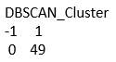
Strides Pharma was the Outlier we found through DBSCAN which had extreme values and even plotted it.

Conclusion: Analysis reveals three distinct pharmaceutical performance segments driven primarily by profitability (ROE, ROCE) rather than liquidity metrics. Strong ROA-ROE correlation (0.93) confirms consistent capital efficiency patterns across the sector. Key findings show that the top-performing segment combines superior margins with conservative leverage; mid-tier companies offer stable returns. Hierarchical clustering suggests consolidation opportunities exist within similar sub-clusters. Portfolio diversification across segments provides better risk-adjusted returns than concentration in any single cluster.

